Band of sisters: the female doctors who became war heroes against the odds
BMJ 2019; 367 doi: https://doi.org/10.1136/bmj.l6747 (Published 17 December 2019)Cite this as: BMJ 2019;367:l6747
- Article
- Related content
- Metrics
- Responses
- Chris Holme, freelance historian
Author affiliations
- cholme@outlook.com
Rejected by the British war effort in 1914 because they were women, a band of medics took their considerable skills across the channel to France. Chris Holme traces their story with the help of newly available documents
In the summer of 1914 the British War Office turned down a generous offer from a Scottish physician, Elsie Inglis, to set up a military hospital entirely staffed by women. She was told to “go home and sit still.”
Undeterred, Inglis found a willing host in France. Against all odds, the all female organisation she set up established the longest serving voluntary hospital treating French soldiers on the western front in the first world war, holding together in the face of horrendous waves of casualties.
By the war’s end, they were back home and exhausted. And there it might have all ended. But the sisterly bonds of comradeship forged at Royaumont Hospital—a generation before those recounted in Stephen Ambrose’s Band of Brothers—were so strong that the women continued to meet for more than 50 years. Now their newsletters are available online, providing fresh insight into their experiences.1

Gusto and ingenuity
Inglis founded the Scottish Women’s Hospitals with the help of the National Union of Women’s Suffrage Societies (NUWSS). Volunteers and money poured in from Britain and around the world.
It created valuable opportunities for medical women, who were barred from joining the Royal Army Medical Corps at the time. By the end of the war, women staffed 12 Scottish Women’s Hospital units in Serbia and around Europe. France provided the medieval abbey of Royaumont, north of Paris, and the first contingent—led by a Liverpool surgeon, Frances Ivens—arrived in December 1914.
Lesser souls would have been daunted by the challenges of creating wards, kitchens, food supplies, and living quarters from the rundown abbey. But these women set about things with gusto and ingenuity.
Among those joining Ivens was Cicely Hamilton, a celebrated actress, author, and feminist. Her fluent French and book keeping skills saw her appointed hospital administrator. Hamilton had been roped into the project by her friend Vera Collum, head of the NUWSS press office. At Royaumont, the freelance journalist Collum made herself useful by becoming a highly proficient radiographer, under the supervision of other radiographers at the hospital. She was a tough cookie, returning twice after serious injury with radiation burns and after her ship was torpedoed.2

Royaumont wasn’t the first all female unit in France. Flora Murray, another Scottish medical pioneer, and the physician Louisa Garrett Anderson set up a military hospital for French troops in Paris, operating out of the new Claridge Hotel on the Champs-Élysées.
In 1915, when the War Office relaxed its ban on women, Murray and Garrett Anderson established a hospital at Endell Street in London’s Covent Garden. It was more overtly suffragist in its approach, a message probably not lost on the British patients—old enough to sacrifice life and limb for king and country but not to vote. The Representation of the People Act 1918, which enfranchised women over 30, also did the same for 40% of the British male population who were not property owners and were hitherto also excluded.
Most of the all female staff at Royaumont were suffragists, but not all. One of the cooks, Dorothy Littlejohn, didn’t approve of female doctors either—contrary to the views of her father, Henry Littlejohn, who was Edinburgh’s first medical officer of health.
It was new and daunting work. Many staff had never treated male patients, and no one had experience of battlefield wounds. Language was also a challenge: most patients were ordinary French soldiers drawn from metropolitan France, north Africa, and Senegal.
And it was no place for prissiness. One new orderly was particularly aghast that white women were nursing black soldiers. Matron judged her to be useless, and she wasn’t missed when she left.3

Broken bodies
In quiet periods the staff treated local civilians and had the time to explore and have some off-duty fun. Daily life was also recorded on canvas by the orderly Norah Neilson Gray, one of the “Glasgow Girls” school of artists, including a striking picture of Ivens inspecting a patient in the cloisters of the 13th century abbey (fig 1).
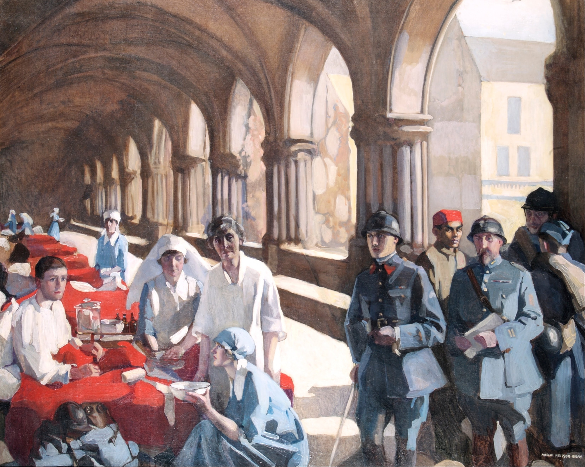
- Download figure

- Open in new tab

- Download powerpoint
Fig 1 A painting by Norah Neilson Gray, an orderly and later renowned artist, captures Frances Ivens tending to a patient in Royaumont Abbey
Royaumont Hospital rapidly grew from 100 beds to 600, taking in another hospital at Villers-Cotterêts nearer the front.
Lulls in fighting didn’t last long. Major offensives brought endless convoys of bloodied, broken bodies. The women worked for days with little or no sleep, sometimes operating or amputating under candlelight and under artillery or aerial bombardment. It also wasn’t a place for pulling rank. Surgeons, nurses, radiologists, drivers, cooks, and orderlies all worked together as a team.
Fame brought recognition. The French president, Raymond Poincaré, and his wife visited in 1916. A film made in 1917 by the French army’s propaganda unit was unpopular with the women, not least because it featured a faked operation and gave the impression of a relaxed holiday camp—far removed from their reality.
Ivens and her colleagues pioneered new techniques to treat the dreaded scourge of gas gangrene, including efficient cleaning of deep wounds assisted by radiographical diagnosis.4
After the war, annual dinners were held in London alongside local meet-ups throughout the year. The women’s children were affectionately known as the Royaumontite “cubs.” Pride of place was given to Ivens, “la Colonelle.” When she married in 1930, Royaumontites made up a guard of honour at Liverpool Cathedral.

Honours
Female doctors were still patronised, marginalised, or ignored in the years after the war, but the lasting contributions made at Endell Street and Royaumont were immense. These were the first women to contribute hospital based research papers to The BMJ and the Lancet.4 They strove not just to be good enough but to be the very best.5
The medical student Margaret Fairlie, for example, was one of the original orderlies in 1914 and rose to be the first female professor of any discipline at a Scottish university, being appointed chair of obstetrics and gynaecology at St Andrews in 1940.
There were no British medals for the Royaumontites, although a grateful France festooned them with 30 Croix de Guerre. Ivens was one of the first foreign born women to receive France’s highest award, the Légion d’honneur.
Laurence Binyon’s poem For the Fallen resonates every Armistice Day. As a volunteer ambulance driver in 1917 he had visited Royaumont, and he wrote: “If there had been diffidence at first, it was amply made up for by the warmth of recognition when it was seen how admirably these women could administrate, organise, operate and nurse.”

Footnotes
- Competing interests: I have read and understood BMJ policy on declaration of interests and declare no relevant interests.
- Provenance and peer review: Commissioned; not externally peer reviewed.

References
- ↵
Royaumont Association. Newsletters, digitised by the Royal College of Physicians of Edinburgh.https://www.rcpe.ac.uk/heritage/womenswork100-scottish-womens-hospital-royaumont.
Google Scholar
- ↵
  - Crofton E
. The women of Royaumont: a Scottish women’s hospital on the western front.Tuckwell Press, 1997: 285-6.
Google Scholar
- ↵
  - Crofton E
. The women of Royaumont: a Scottish women’s hospital on the western front.Tuckwell Press, 1997: 177-80.
Google Scholar
- ↵
  - Ivens F
. The preventive and curative treatment of gas gangrene by mixed serums. BMJ1918;2:425-7.doi:10.1136/bmj.2.3016.425. https://www.ncbi.nlm.nih.gov/pmc/articles/PMC2341884/.https://www.bmj.com/content/2/3016/425. pmid:20769223
FREE Full TextGoogle Scholar
- ↵
  - Geddes JF
. Deeds and words in the suffrage military hospital in Endell Street. Med Hist2007;51:79-98.doi:10.1017/S0025727300000909. https://www.ncbi.nlm.nih.gov/pmc/articles/PMC1712367/.https://www.cambridge.org/core/journals/medical-history/article/deeds-and-words-in-the-suffrage-military-hospital-in-endell-street/A15A02BE6880FCC585A16853471BF0AD. pmid:17200698
CrossRefPubMedGoogle Scholar
View Abstract

